|  |  |  |
| --- | --- | --- |
| Luke Pepin | CSE 4400 - HW 3 | 3/28/2025 |

1. File Permissions:
   1. /etc/passwd

The permissions of /etc/passwd are”-rw-r--r--.” This means the owner has read write permissions while groups and others only have read permissions. This makes sense since passwords are verifiable by all users, however only the system administrator can create new passwords.

* 1. Mount

The permissions of mount are”-rwsr-xr-x". This means the owner has read, write and setuid bit (the file when ran will run with owners' permissions). Groups and others only have read and execute permissions.

* 1. user seed groups

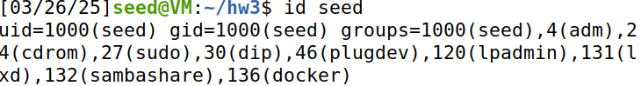The primary group for user seed is 1000(seed).

The supplemental groups are 4(adm), 24(cdrom), 27(sudo), 30(dip), 46(plugdev), 120(lpadmin), 131(lxd), 132(sambashare), 136(docker)

* 1. new file permissions

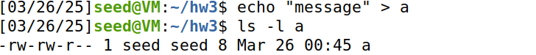A's permissions give the owner read and write and similarly group has read and write permissions. The associated userid and groupid are seed.

* 1. chmod permissions

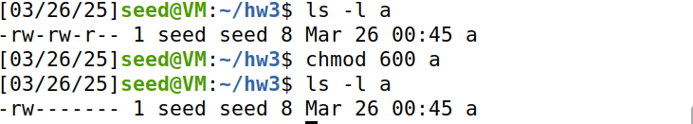Using the command chmod 600 a, the permissions have been changed such that the group and others have no permissions associated with the file a.

* 1. chown group

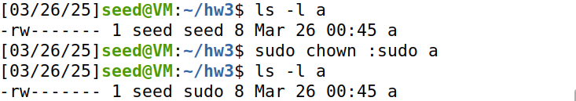The group asscioated with file a has been changed to sudo with the ”sudo chown :sudo a” command.

* 1. Change group to ssh

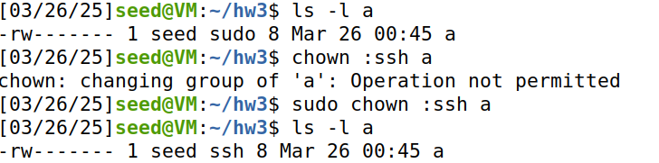The group associated with a has been changed to ssh with the same command as previously. However, this was after a failed attempt to change the group without starting with ”sudo”, this failed because the user lacks the admin privileges to modify group ownership to a group they do not belong to.

* 1. Change group to seed

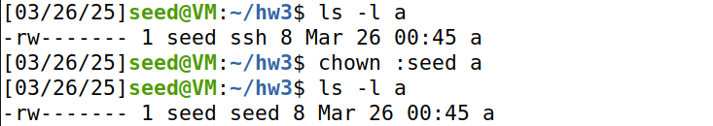The group was once again changed using the same commands. Sudo is not required to change the group of a to seed since the seed is part of the group that user belongs to.

* 1. umask value

The umask value of 0002 means files have the default permissions of rw-rw-r—while directories have the default permissions of rwxrwxr-x.

* 1. Change umask group

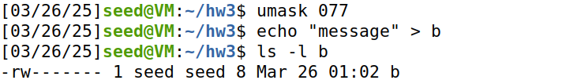The umask value for removing the permissions of groups and other users while remaining permissions for owner is 077.

1. Bash Scripts:
   1. Change the permissions of two files

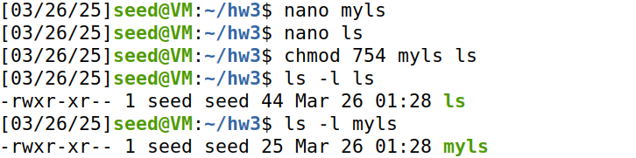File creation and change of permissions with chmod 754, resulting in permissions of –rwxr-xr--

* 1. List of directories in PATH in bash session

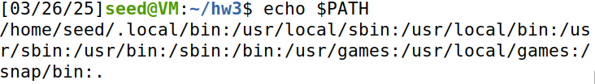Command shows list of directories in PATH

* 1. PATH=. Myls

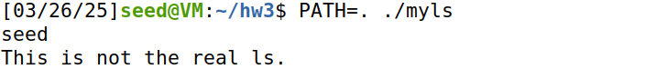By setting PATH=., bash includes the current directory ”.” in the l;ist of executables. As a result when myls runs it uses the ls script in the current directory.

* 1. Change to myls

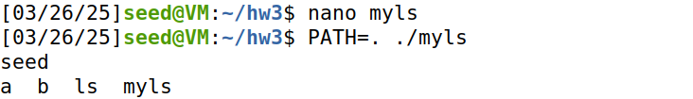The ls line in myls was changed to /bin/ls $* which ensures the script runs the real ls command as the line specifies its full path, leaving no area of interpterion for accidently running the fake command in the current directory.

* 1. Change owner to root and set SUID bit

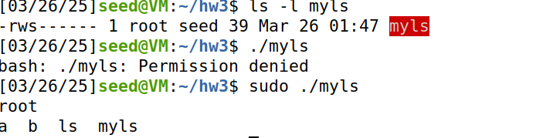The owner was changed to root with the command ”sudo chown root myls”, the permissions was changed with the command ”sudo chmod u+s myls” to get the set SUID bit. When running the script normally permission is denied since seed lacks the read and execute permissions on the file. However, when running the script with sudo the output is as expected, where root is displayed because whoami runs the script with root privileges and the files in the current directory are listed correctly.